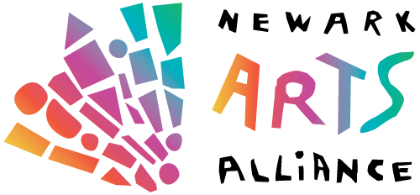
Application Form for
Solo and Group Show 2021

Postmarked by or delivered to the NAA by October 1, 2021
Newark Arts Alliance Attn: Exhibition Committee 276 E. Main Street, Suite 102 Newark, DE 19711
Incomplete applications cannot be considered

Name & Art Medium
Address
City, State, Zip
Phone
E-mail
For groups
Additional artist’s names and mediums
Proposed Show Title
Description of Show’s Theme

(Office use only)
Images Image List Artist’s Statement Resume Fee

