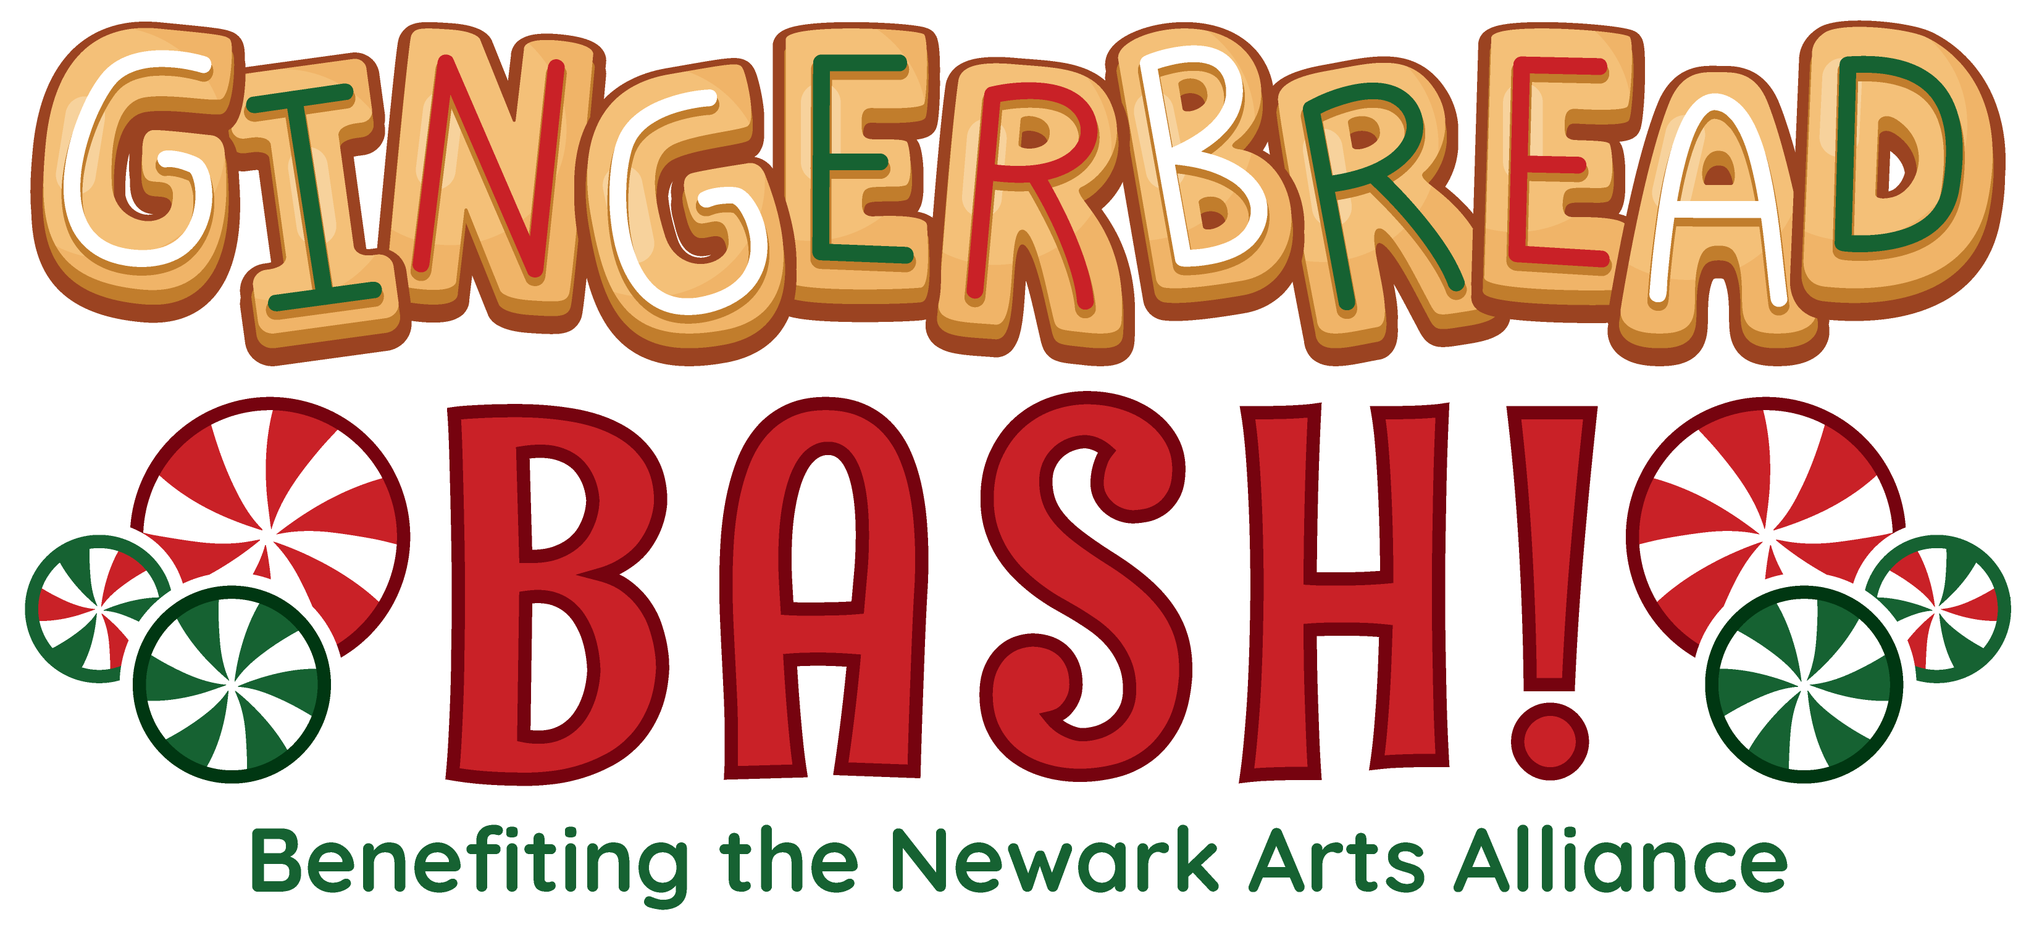

Entry Form
Name of primary contact
Email |  |  |  |  |  |  |  | Phone
Street Address
City |  |  |  |  |  | State |  |  |  | ZIP
 | Individual Entry (ages 18+) |  |  |  |  |  | Group Entry (all ages; primary contact must be 18+)
Names of group members

Submitting your entry
- Entry Fee $10 (non-refundable)
- All gingerbread houses with entry forms must be dropped off on Saturday, Dec. 4, 5pm to the Newark Country Club. Winners announced at the Gingerbread Bash by 8pm. Work will be available for pick up after the event at the Country Club at 8:30pm. Any work not picked up will be brought to the Newark Arts Alliance for pick up the following week.
- One entry per person/group
- Prizes will be offered for “$100-Best of Show”, “$100-People’s Choice” and “$50- Honorable Mention”
- Winners will be chosen by Chef Andrew Thorne of Home Grown Café. Chef’s judging guidelines are available on request. Email Terry at terry@newarkartsalliance.org
Drop off entries to: Newark Country Club, 300 West Main St., Newark, DE 19711

Payment:

 | Check/Credit | Make check payable to Newark Arts Alliance
 | In-office payment | Cash, check, or charge accepted

Credit Card Payment:
Card # __________________________________ Expiration: ___________ CVV: ________

Newark Arts Alliance, 276 E. Main St., Suite 102, Newark, DE 19711 302-266-7266
info@newarkartsalliance.org www.newarkartsalliance.org

